Procedure for Infection Control

Disclaimer:
Any policies, procedures, guidelines, templates, or information provided on the GRCReady website are offered as general guidance only and should be used as a reference. It may not take into account all relevant state or federal laws and is not a legal document. All information in this site is provided “as is”, with no guarantee of completeness, accuracy, timeliness or of the results obtained from the use of this information.

Contents
1 Overview 2
2 Scope 2
3 Actions 2
3.1 First Aid Risk Assessment 2
3.2 First Aid Kits 2
3.3 Additional First Aid Equipment 2
3.4 First Aid Rooms 3
3.5 First Aid Signs 3
3.6 First Aid Personnel 3
3.7 Training and Competence Requirements 3
Appendix A: First Aid Risk Assessment Guide 5

Purpose
This procedure addresses workplace infection control of communicable diseases. It includes generic requirements of infection control, as well as specific requirements for issues arising from provision of first aid to injured workers and from contaminated sharps, such as hypodermic needles, and other biological hazards, including waste.

Scope
This business procedure applies throughout [ORGANISATION], all its sites and all activities under [ORGANISATION]’s control. It applies to all [ORGANISATION] employees and contractors, including visitors to [ORGANISATION] workplaces.
Personnel most at risk of infection are site first aid providers, cleaners and those with the responsibility for the disposal of biological waste.

Treating Injured Workers on Site
First aiders should take standard precautions to avoid becoming ill and exposing others to illness when handling blood or body substances. Standard precautions are work practices that are applied to all patients and their blood and body substances, regardless of their infectious status, to ensure a basic level of infection prevention and control. These include use of personal protective equipment (PPE), hand hygiene, cleaning techniques and managing spills of blood and body substances, and appropriate handling and disposal of sharps and waste.

Suitable PPE for Infection Prevention and Control:
Where PPE is used, it must be properly selected for the task, be readily available, clean, and properly maintained. First aid personnel shall be trained in the correct use of the equipment provided. PPE should comply with relevant Australian Standards.
Disposable PPE that has been in contact with blood or body substances should not be reused and should be disposed of in the Hazard Bag.
Non-disposable PPE should be cleaned and sterilised.
Protective gloves - These should be worn whenever there is a potential for contact with blood or body substances. Disposable PVC or latex gloves should not be reused. Heavy-duty gloves may be worn where a higher level of protection is required, for example, where there is a risk of exposure to sharp objects or when cleaning a blood or body substance spill.
Protective clothing – Clothing, such as disposable non-porous overalls, or plastic aprons, should be worn in situations where there is a risk that clothing of first aid personnel or workers undertaking clean up tasks may become contaminated with blood or body substances.
Eye protection - Goggles and safety glasses should be worn, where there is a risk of blood or body substance splashes entering the eyes, for example, arterial bleeding injuries.
Safety footwear - Safety footwear should be worn where there is a risk of the feet being punctured by sharp objects, such as broken glass or hypodermic needles.
Resuscitation mask - Expired air resuscitation (EAR) may involve exposure to blood and body substances. Use of a resuscitation mask, for mouth to mask resuscitation, reduces this risk. A resuscitation mask should only be used, if first aid personnel have received instruction in its use.

Providing First Aid
Before providing first aid to an injured or ill person, first aiders should assume they could be exposed to infection.
First aiders should:
- Wash their hands with soap and water or apply alcohol-based hand rub before administering first aid.
- Wear personal protective equipment to prevent contact with blood and body substances, including disposable gloves.
- Wear eye protection, a mask and protective clothing may also be necessary if splashes of blood or body substances are likely to occur. If available, a plastic apron should be worn to protect clothing.
- Make sure a suitable waterproof dressing covers any open cuts, wounds or abrasions they have.
- A surgical mask should be used if available - particularly if the first aider is suffering from a cold or virus. Avoid talking directly over a wound or coughing over an open wound.
- If resuscitation is required use a resuscitation mask such as a Pocket Mask or Life Key as protection barriers.
- Wash hands after contact with blood, body fluids or contaminated items, and after removal of protective gloves.
- Any part of the body that comes in contact with blood or body substances should be washed with soap and water immediately.
Skin penetrating injuries that are obviously contaminated with soil, dust or manure or deep penetrating wounds, are the types of wounds likely to favour the growth of tetanus organisms. Workers over the age of 50 years who have never been vaccinated or who have not maintained adequate immunity through vaccination are at greatest risk of tetanus. Disinfection of the injury site within 4 hours of the injury will reduce the risk of infection. Immediate medical attention is to be sought in particular for deep penetrating wounds and injuries to workers who have not been immunised or cannot remember when they were last vaccinated.

Actions Following Treatment
- Contaminated clothing should be removed, and soaked in the strongest household bleach (1 part bleach to 9 parts water) for at least 30 minutes. Clothing can then be washed in the normal way, using washing detergent and the hottest possible water. Alternatively, the contaminated clothing can be discarded in a hazard waste bag for disposal.
- Disposable clothing and PPE can be discarded in a hazard waste bag for disposal.
- Any surfaces that were used e.g. bench or tabletop, should be washed thoroughly with a disinfectant or household bleach, which can be left to soak for 30 minutes.
- Any instruments that may have been used should be soaked in a Hibitane solution, or steam sterilised prior to reuse.
- The first aid provider is responsible for ensuring the First Aid Kit is re-stocked after use.

Action in the Event of Exposure to Blood or Body Substance Spillage
In the event that a worker does come into contact with blood or body substance spillage, and they are exposed, the following immediate action is required:
- If skin is penetrated, wash the area well with soap and water (alcohol-based hand rinses, or foams, 60-90 per cent alcohol by weight, should be used when water is not available). Refer to section 3.1 for further information. If blood gets on the skin, irrespective of whether there are cuts or abrasions, wash well with soap and water.
- If the eyes are contaminated, rinse the area gently, but thoroughly, with water or normal saline, while the eyes are open.
- If blood gets in the mouth, spit it out, and then rinse the mouth with water several times. Then report IMMEDIATELY to your Supervisor, who will take appropriate action.
- Report the exposure and where appropriate complete a Notification of Infectious Disease Form (See Appendix A for an example).

Management of a Blood or Body Substance Spillage
Cleaning should commence as soon as possible after an incident involving blood or body substances has occurred. Protective gloves must be worn during clean-up work. Absorbent material, such as paper towels, should be used to absorb the bulk of the blood or body substance. These contaminated materials should then be disposed of in a leak proof, sealed, hazard waste bag.
The area should be cleaned with warm water and detergent, and then disinfected. A suitable disinfectant is a freshly prepared 1:10 dilution of 5% sodium hypochlorite (household bleach) in water. Mops and buckets should be rinsed with warm water and detergent and stored dry. After cleaning the contaminated area and the cleaning equipment, reusable gloves and other protective clothing should be removed and placed in the hazard waste bag.

Handling Needles and Other Sharps
Handling needles and sharps involves potential exposure to biological hazards, such as hepatitis B, C and HIV virus. The person who uses a needle or sharp, is responsible for its safe disposal.
Infection control procedures, when handling needles, and other sharp contaminated objects, include:
- Always assess the risk and wear suitable PPE.
- Never attempt to recap or bend used needles.
- Handle syringes by the barrel.
Place contaminated sharps in an appropriate puncture proof container: i.e., one that is yellow, labelled ‘Danger Contaminated Sharps,’ and marked with a black biohazard symbol.
Sharps containers shall be located at every first aid facility.
Refer to Appendix B: Personal Protective Equipment for Infection Control.
If a first aider sustains a sharps injury or thinks they are at risk of infection from blood or bodily fluid contamination, they should seek prompt medical advice.

Action in the Event of Exposure from a Needle Stick Injury
A needle-stick injury can cause considerable stress to the worker and their family. While the risk of contracting a blood-borne pathogen is relatively low, the psychological trauma that follows the injury can be considerable. The uncertainty of health outcomes of such an injury and the significant time (approximately 6 months) required to determine whether the worker’s health has been compromised contributes to the stress. Immediate intervention will assist the worker in coming to terms with the potentially dangerous and health threatening event and immediate medical treatment may prevent infection.
The provision of counselling can mitigate the psychological consequences of the exposure.

Controls
When undertaking work activities where potential sharps hazards exist (e.g. carrying and / or otherwise handling rubbish, work in public access areas etc.), the following general precautions apply.
Do not:
- manually compress rubbish bags;
- hold rubbish bags close to the body / limbs;
- hold the base of rubbish bags;
- attempt to recap, bend or cut discarded sharps;
- place hands or fingers into areas or objects where sharps may be concealed (e.g. rubbish bins, drains, pits, behind toilets, thick bushes etc.).
[ORGANISATION] workers who may be exposed to body fluids / substances via sharps hazards are to be offered appropriate vaccinations.

Person Exposed
In the event that a worker incurs a needle stick injury, and they are exposed, the following immediate action is required:
- Wash the area well with soap and water (alcohol-based hand rinses, or foams, 60-90 per cent alcohol by weight, should be used when water is not available).
- Report IMMEDIATELY to their Supervisor, who will take appropriate action.
- The exposure must be recorded on an Event Notification form.

Treating First Aider
- Arrange for immediate medical assessment by a Doctor for the affected person.
- Ensure that the exposed area has been washed thoroughly.
- Find out whether a known source is involved in the incident and arrange for testing of the source material to occur, as soon as possible.
- If the known source is a person, request them to attend a nominated medical practitioner’s surgery for blood tests. Inform them that their attendance is entirely voluntary, and that it is likely their blood would be tested for:
  - HIV antibody;
  - Hepatitis B surface antigen (HBsAg); and
  - Hepatitis C antibody (Anti-HCV).
- Contact the Occupational Health Nurse who will arrange on-going support and counselling for the affected person.

Waste Management
Contaminated waste must be placed in a leak proof bag, or container and sealed (bags or containers must have a biohazard symbol on it), the bag or container shall not be overfilled. Gloves must be worn when handling contaminated hazard waste bags and containers.
Sharps, including scissors and tweezers, that have become contaminated with blood or body substances should be disposed of in a rigid-walled, puncture-resistant sharps container by the person that used them. The materials, design, construction, colour and markings of sharps containers should comply with:
- AS 4031-1992 – Non-reusable containers for the collection of sharp medical items used in health care areas
- AS/NZS 4261-1994 – Reusable containers for the collection of sharp items used in human and animal medical applications.
Waste disposal shall comply with EPA, or local government requirements.

Review
This Document is required to be reviewed, as a minimum, every 5 years.

Definitions
Term | Meaning
Affected Person | The person exposed to biological contamination e.g. blood, or body fluid, as a result of a needle stick injury.
Body Fluids | Includes blood, saliva, vomit, puss, urine, faeces, vaginal fluid, seminal fluid, and breast milk.
Exposure | For the purpose of this procedure exposure means inhalation, ingestion or penetration of skin with an object that may have biological contamination.
First Aid | The immediate care given to an ill or injured person until more advanced care arrives or the person recovers.
Sharps | Objects (e.g. needle or similar) that may be contaminated with body fluids / substances and are capable of causing a skin penetrating injury.
Sharps Container | An approved puncture-resistant container designed in accordance with:  - AS/NZS 4261:1994 / Amdt 1:1997 - Reusable containers for the collection of sharp items used in human and animal medical applications; or  - AS/NZS 4031:1992 Amdt 1996 – Non-reusable containers for the collection of sharp medical items used in health care areas.
Source | The source of the biologically contaminated material, or substance, the Affected Person was exposed to e.g. the person whose blood or body fluid was inoculated, or splashed onto, the affected person. Sometimes the source may not be identifiable, for example, when an affected person has been injured by a needle/instrument, and it is not known on what or whom it was used.

Appendix A: Sample Notification of Infectious Disease Form
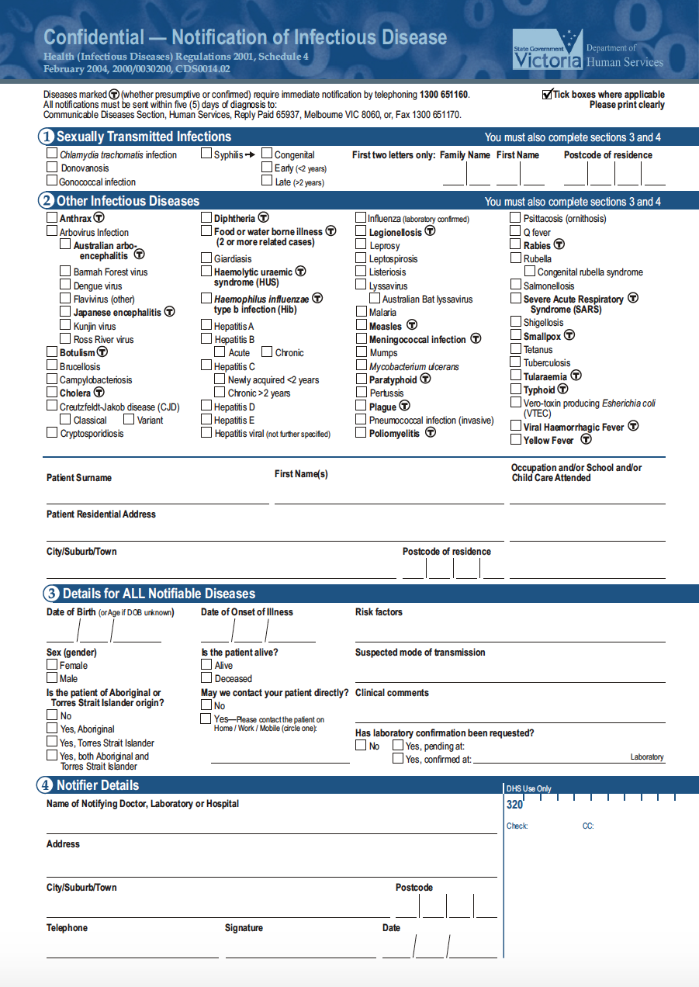

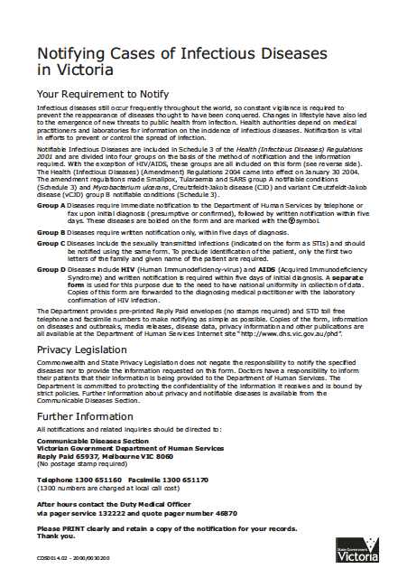

Appendix B: Personal Protective Equipment for Infection Control
A typical Infection Control Kit can comprise:
Self Compiled Kit: | Commercially Bought Kit:
- Mouth to Mask Pocket Mask  - Disposable mask (if available)  - Heavy duty gloves  - Disposable gloves  - Plastic bag  - Goggles or eye shields.  - Heavy duty disposable ‘Hazard Bag’ | - Absorbent cloth and scissors  - Antiseptic ampoule and hand towelette  - Latex gloves and apron  - Blood spill sachet  - Face mask with eye shield  - Scoop and scraper  - Yellow disposable ‘Hazard Bag’

